ITE3006

Information Technology Essentials Web

EA2

Name: Tse Man Fung

Student no.: 230026964

table of contents

Common 3

index.html 5

Story.html 6

minigame.html 7

minigame - Reversi 8

Character.html 11

vote.html 14

# Common

Each page consists of three main sections: header, content, and footer.

All headers have a floating animation when the page is loaded (use F5 to see).

For any clickable element:

When the user hovers the cursor over the element,

1. The cursor changes to a pointer.



1. The element's opacity changes, visually altering its color.

For example:



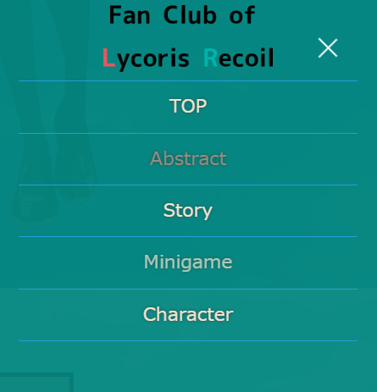

For each page, users can click the button below to display the website's directory.



When the user clicks the directory button, the directory shown in the image below will open.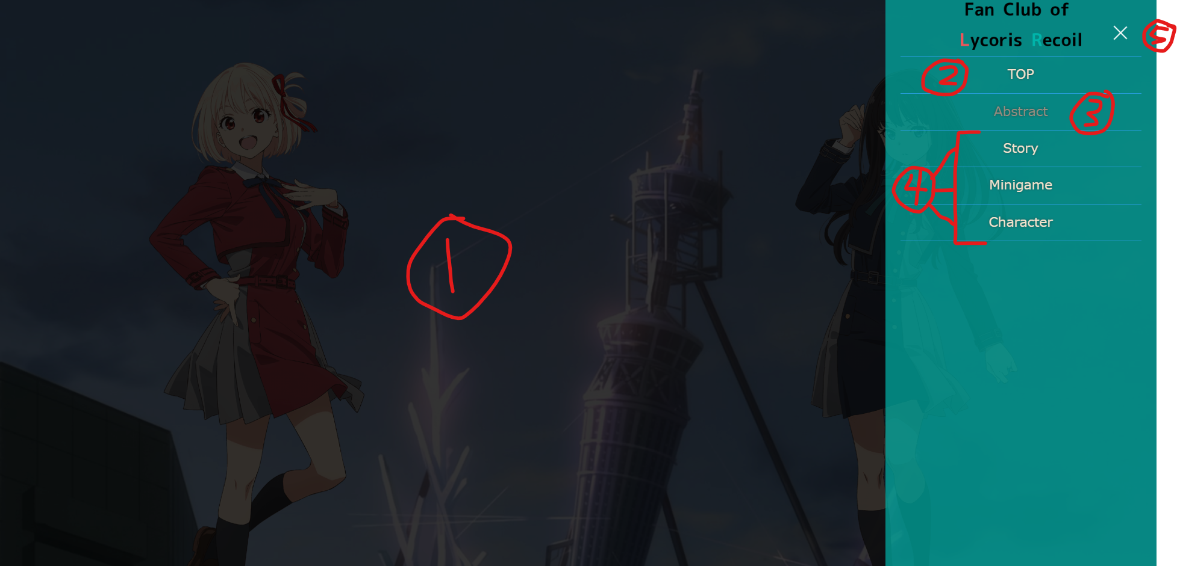

1. Users can close the directory by clicking on the black empty space (1) or the X button (5).
2. Users can click on Top (2) to go back to the top of the page.
3. Users can see the current page they are on (3), which is not clickable.
4. Users can click (4) to navigate to other pages.

Every page has a footer at the bottom.



1. Users can click the two icons on (1) to open the official Twitter (X) and Pixiv accounts.
2. Users can click (2) to go back to the top of the page. (2) is only displayed when the user scrolls down and remains in the bottom right corner.

# index.html

When the user enters index.html (also known as the Abstract page), the following screen appears:

header:

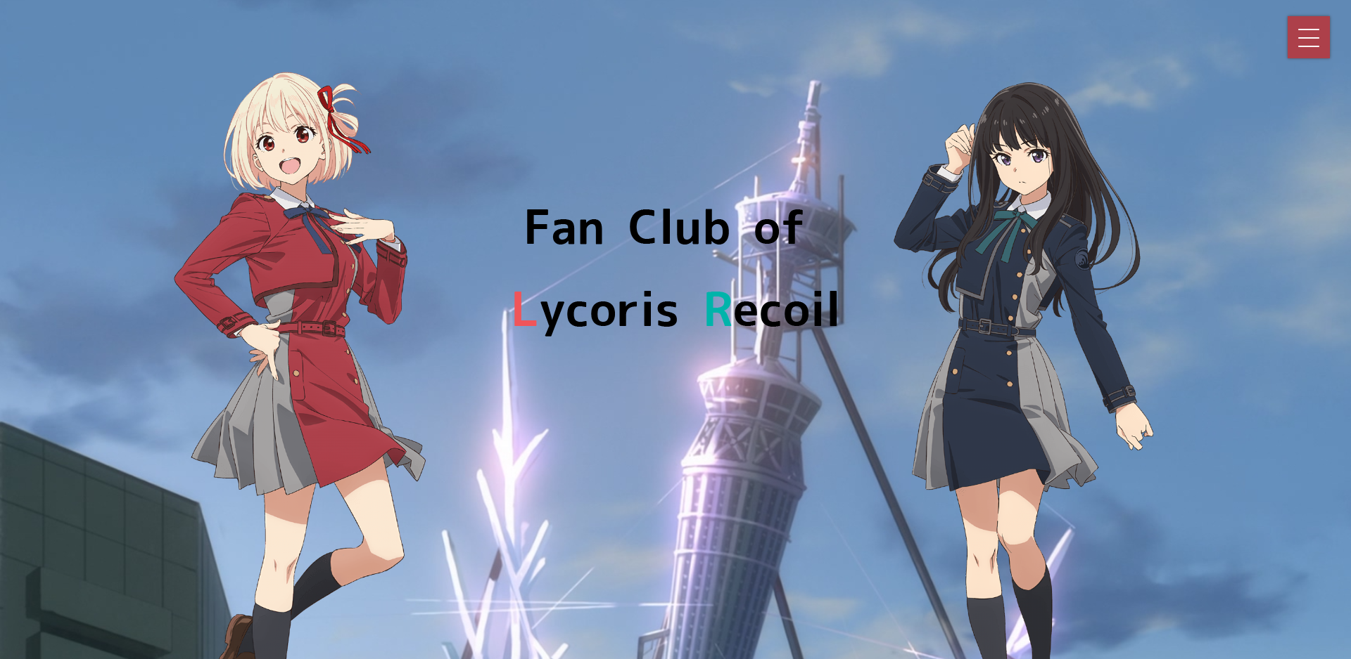

content:

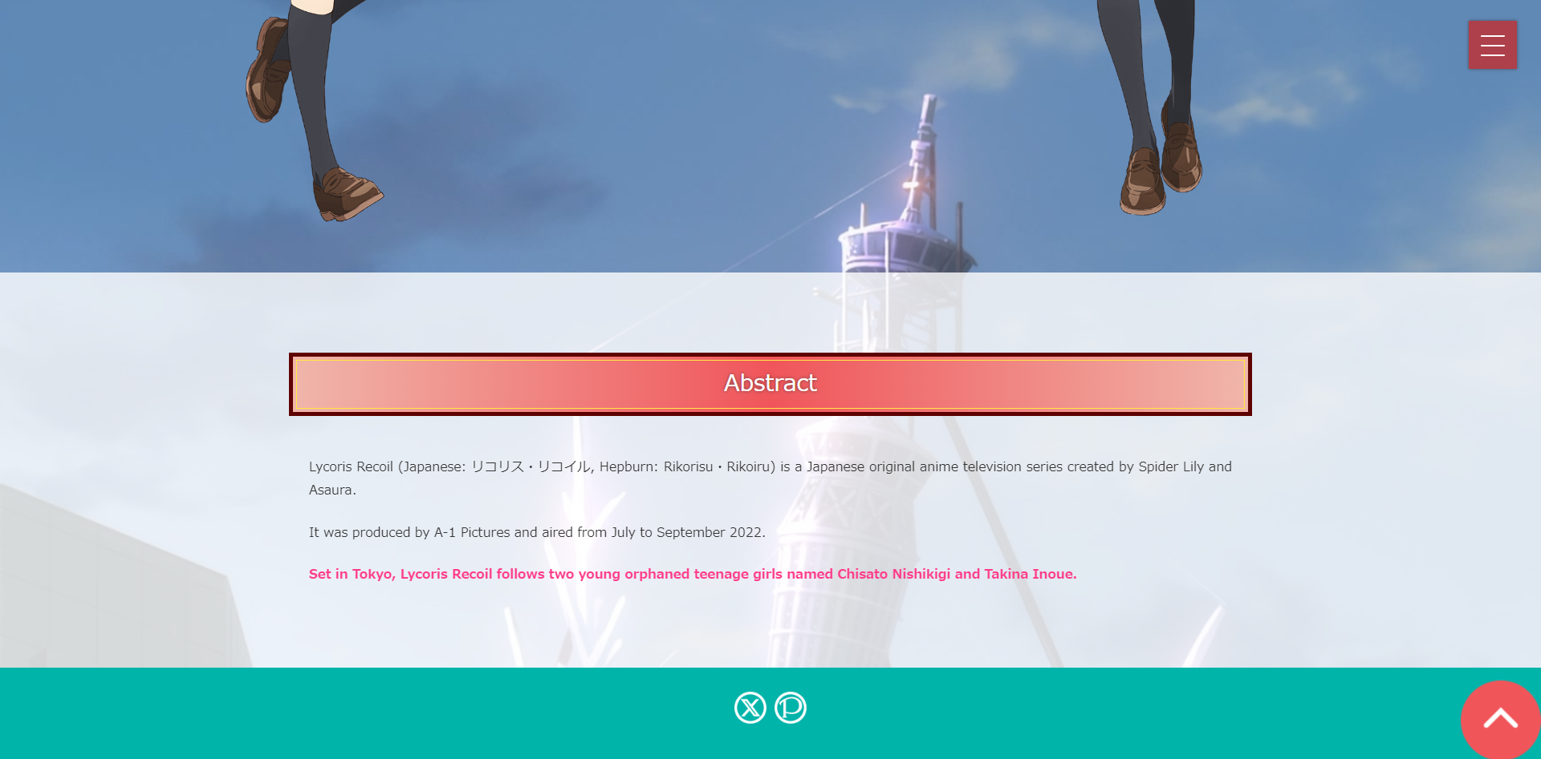

Cursor:

When moving over the header section, the background and characters in the header will move left or right (in the same or opposite direction as the cursor's X-axis).

# Story.html

header:



content:

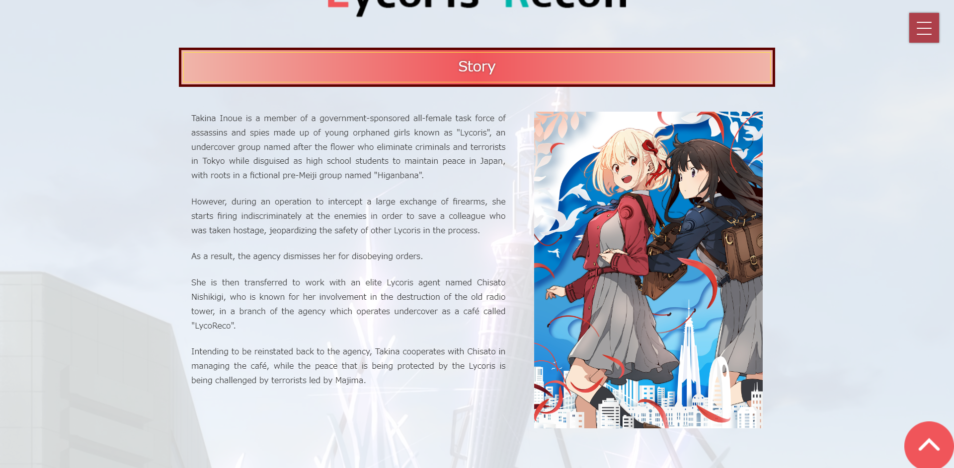

# minigame.html

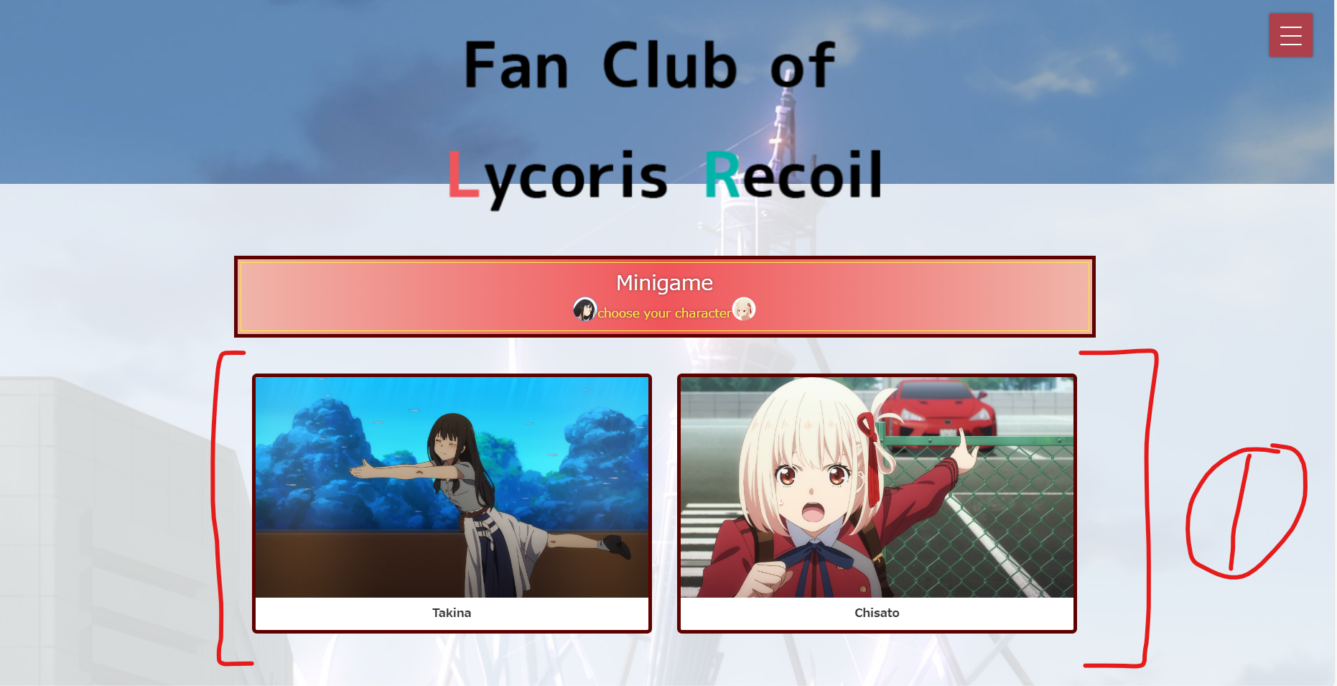

1. Users can select "First Move" or "Second Move" at (1), and the chosen character will affect the pieces and the end screen in the game.
2. (1) is a radio button, and when the user clicks it, the form will be submitted.
3. The form's method is "get."

## minigame - Reversi

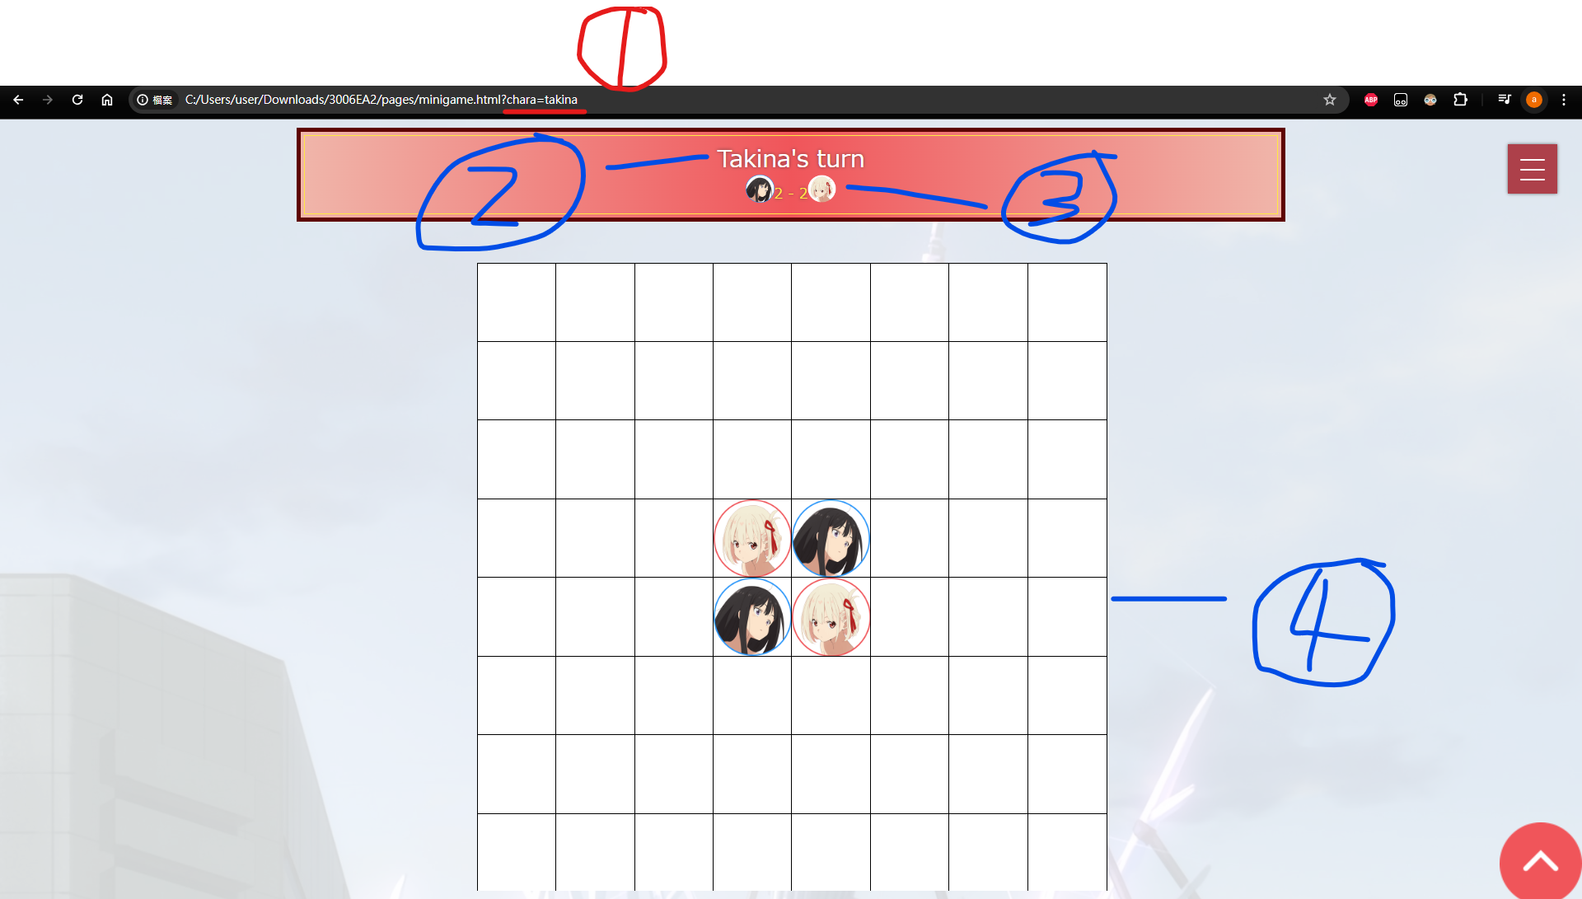

1. (1) is a parameter for JavaScript, determining whether the user goes first or second and the placement of the pieces.
2. Users can see whose turn it is at (2).
3. Users can see the number of pieces for each player at (3).
4. (4) is an 8x8 game board, and users can click on each empty cell, but not all cells can be filled with pieces.
5. For the rules of Reversi,

please refer to:  <https://en.wikipedia.org/wiki/Reversi#Rules>.

Screenshot of a game in progress:

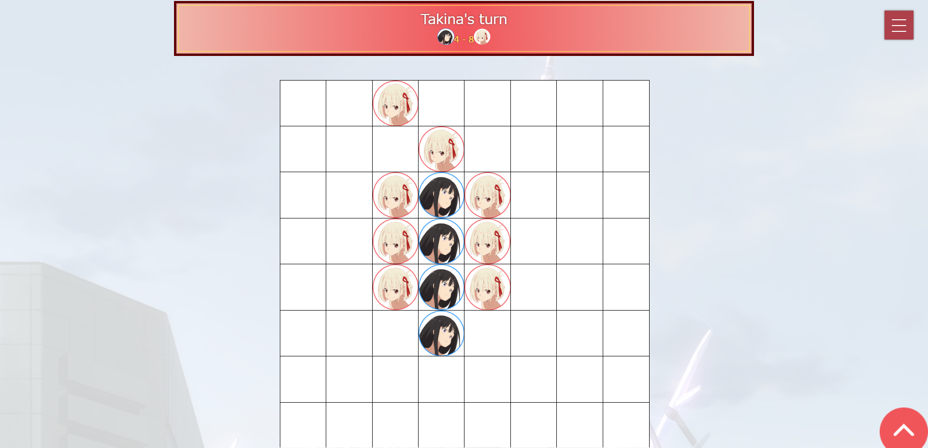

Game Over screen:

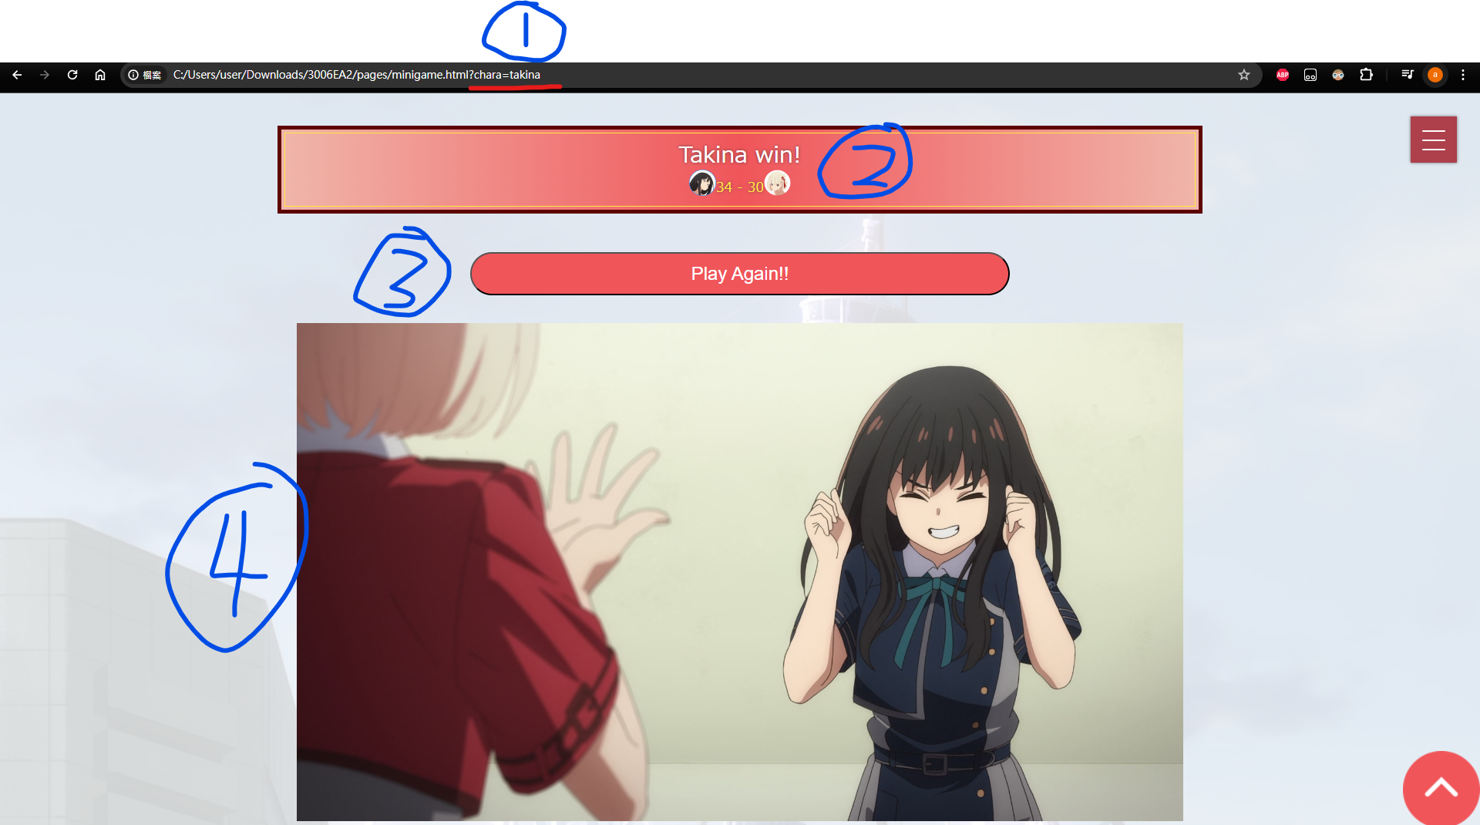

1. (1) is a parameter for JavaScript, which determines the image displayed in (4).
2. Users can see the game's result at (2).
3. Users can click (3) to reset the game board and the page.
4. There are five possible images displayed in (4) for the game's result (user winning or losing when selecting Takina, user winning or losing when selecting Chisato, or a tie).

Game over screen without background: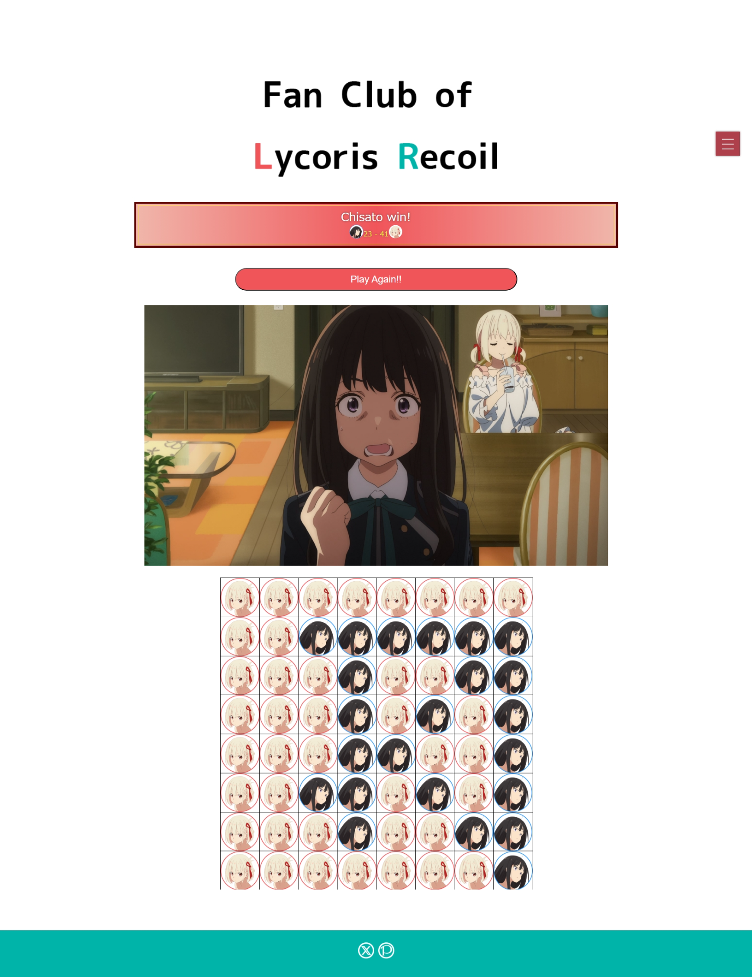

# Character.html

User see:

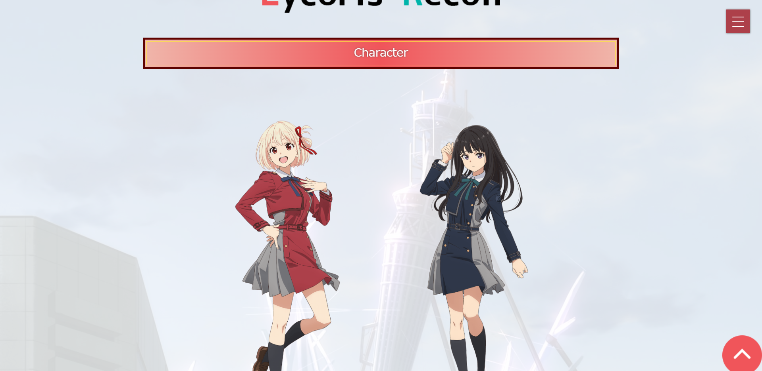

full page with-out background:

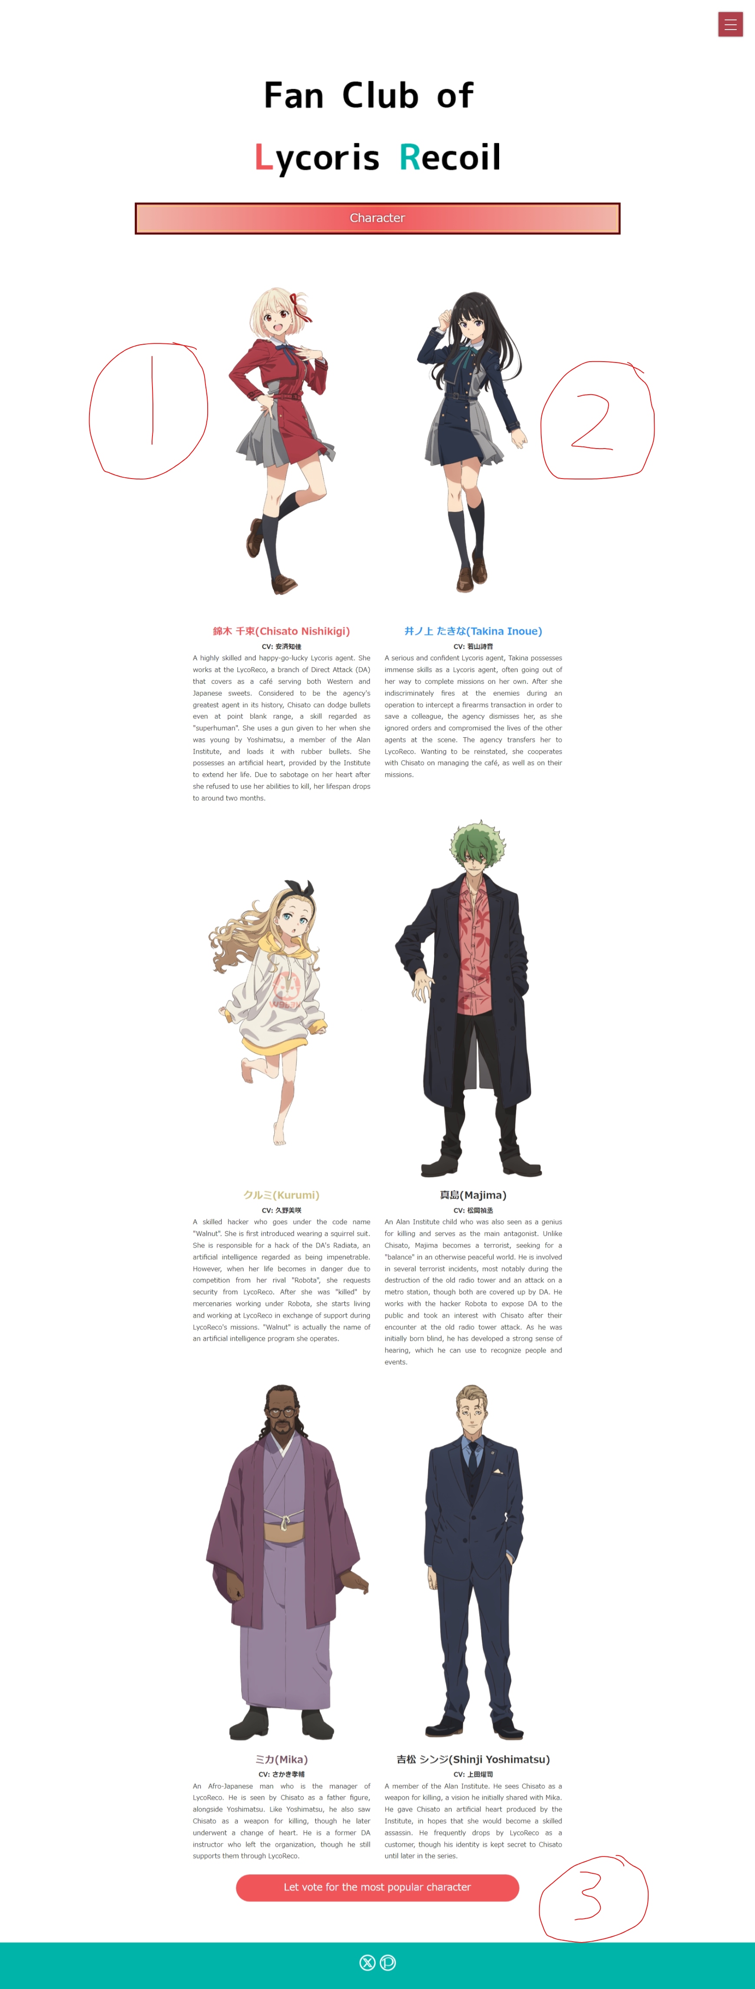

1. When the user hovers over (1) or (2) with the cursor, the corresponding element's image will change.
2. user can click (3) to navigate to vote pages.

# vote.html

full page with-out background:

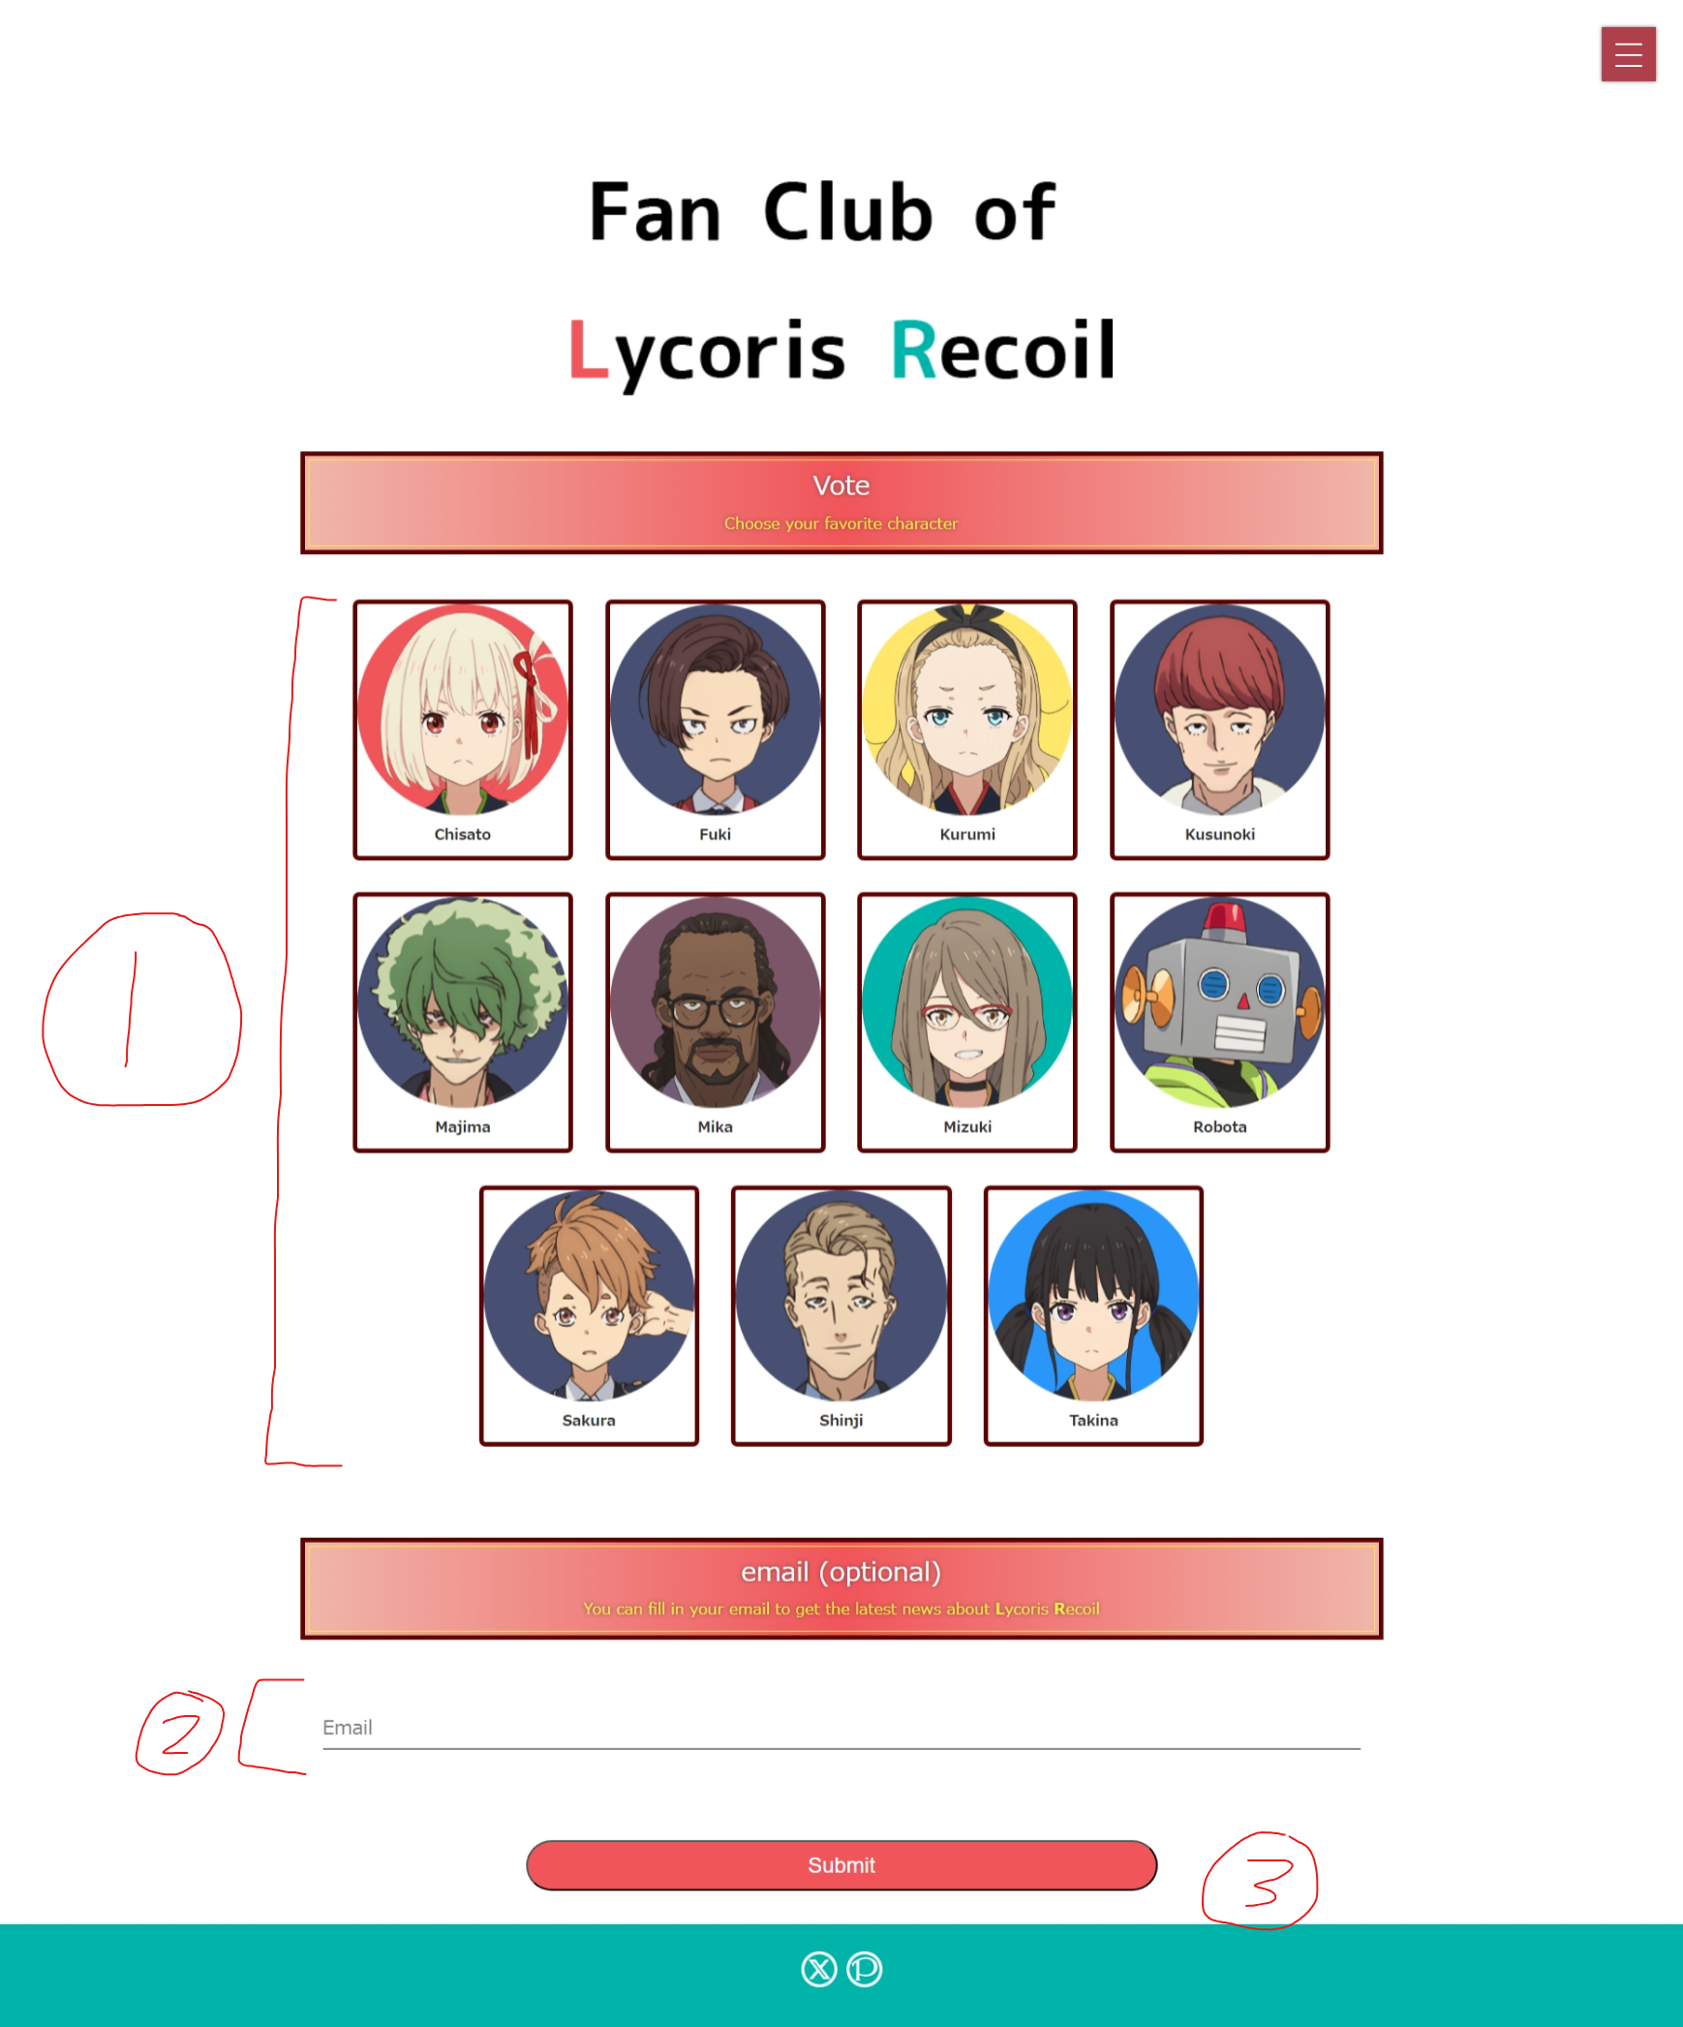

1. (1) is a set of radio buttons.
2. (2) is an input field of type "email".
3. Users can select their preferred character by clicking on the corresponding box.
4. Users can submit their vote by clicking the "Submit" button.
5. The form's method is "post."

When a user clicks on one of the characters, the border color will change. If any other character is subsequently selected, the border of the previously selected character will revert to its unselected style.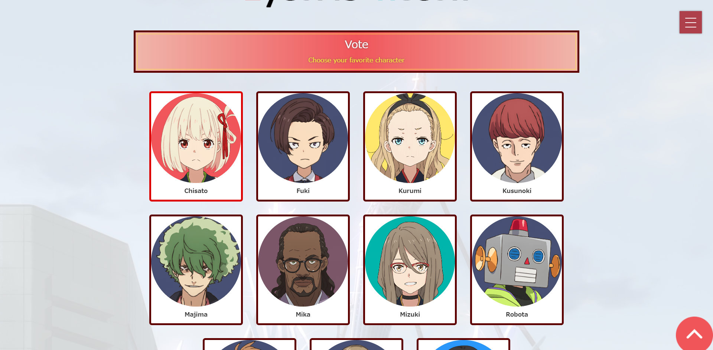

When the user focuses on (2), an animation will appear, and the style will change.



When the user clicks the submit button:

* It will check if a character has been selected.
* If no character is selected, an alert will be displayed.

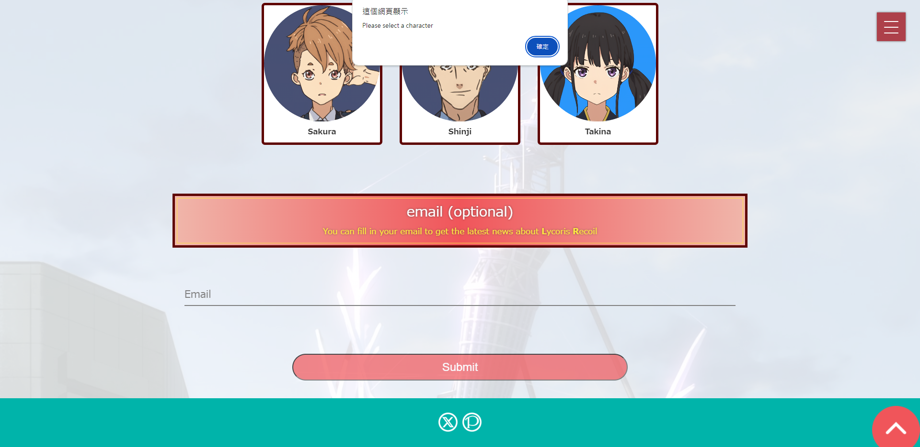

If an email is filled, it will check the email format is correct or not.